
DBMS PROJECT
Resource Booking System
Submitted by:- Submitted To:-
Ashwin Yadav (2100290120057) Ms. Shivani
Aryan Tiwari (2100290120051) (Assistant Prof.)
A-2 Batch CS- 5A CS Dept. KIET

INDEX-
1)Statement about the Problem
2)Objective
3)Scope
4)Methodology
5)ER Diagram
6)Relational Model
7)Queries and Output
8)References

Statement about the Problem:-

Organizations often face challenges in efficiently managing and scheduling resources such as meeting rooms and equipment. The current manual booking system is prone to errors, lacks real-time visibility, and is time-consuming. To address these issues, there is a need for a digital solution—a Resource Booking System—that streamlines the process of reserving meeting rooms and equipment. The objective is to design and implement a robust database system that facilitates seamless resource booking, enhances user experience, and provides administrators with tools to manage and optimize resource utilization.

Objective:-
- Resource Types and Attributes:
  - Define various resource types (e.g., meeting rooms, projectors, laptops) and their specific attributes (e.g., capacity, location, specifications).
  - Establish a comprehensive database schema to store resource information.
- Booking System:
  - Develop a system that allows users to check resource availability and make reservations for specific time slots.
  - Ensure that each resource can only be booked for one activity at a time to avoid conflicts.
  - Implement mechanisms to prevent double bookings for the same resource and time slot.
- User Management:
  - Create user accounts with different roles (e.g., regular users, administrators).
  - Enable users to log in to the system for booking resources.
  - Grant administrators the capability to manage user accounts and access control.
- Reservation Details:
  - Capture and store reservation details, including the resource booked, user information, reservation time frame, and purpose of booking.
- Search and Filters:
  - Implement a search functionality that allows users to find available resources based on criteria such as date, time, location, and resource type.
  - Provide filters to refine search results for a more efficient user experience.
- Notifications:
  - Develop a notification system to inform users about their bookings, upcoming reservations, and any changes or cancellations.
  - Integrate email or in-app notifications to keep users informed in real-time.
- Reporting:
  - Enable administrators to generate reports on resource utilization, popular resources, and user activity.
  - Include features for data analysis to optimize resource allocation.
- Security:
  - Implement robust authentication and authorization mechanisms to ensure that only authorized users can access and modify data.
  - Prioritize data security and user privacy.
- Audit Trail:
  - Maintain an audit trail to track changes to reservation details and user activities, ensuring transparency and accountability.

Scope:-
The scope of the Resource Booking System project encompasses the design, development, and implementation of a comprehensive system for efficiently managing and booking resources such as meeting rooms and equipment. The project aims to address the challenges associated with manual resource booking processes and enhance organizational efficiency. The key components and features within the scope of the project include:
- Resource Types:
  - Define and categorize various resource types (e.g., meeting rooms, projectors, laptops) based on organizational needs.
- Database Design:
  - Develop a robust database schema to store information related to resource types, attributes, availability, reservations, user accounts, and audit trails.
- User Management:
  - Create user accounts with different roles, such as regular users and administrators.
  - Implement authentication and authorization mechanisms to control access to system features.
- Booking System:
  - Enable users to browse available resources, check their availability, and make reservations for specific time slots.
  - Implement a booking mechanism that prevents double booking and conflicts for the same resource and time slot.
- Reservation Details:
  - Capture and store relevant details for each reservation, including the resource booked, user information, reservation time frame, and purpose.
- Search and Filters:
  - Implement a search functionality that allows users to find available resources based on date, time, location, and resource type.
  - Provide filters to refine search results and facilitate a quick and efficient booking process.
- Notifications:
  - Develop a notification system to inform users about successful bookings, upcoming reservations, and any changes or cancellations.
  - Utilize email or in-app notifications to keep users informed in real-time.
- Reporting and Analytics:
  - Enable administrators to generate reports on resource utilization, popular resources, and user activity.
  - Include data analysis features to optimize resource allocation based on usage patterns.
- Security:
  - Implement measures to ensure the security of user data and system access.
  - Address data privacy concerns and adhere to best practices for securing sensitive information.
- Audit Trail:
  - Maintain an audit trail to track changes to reservation details and user activities, providing transparency and accountability.
- User Interface:
  - Develop an intuitive and user-friendly interface for users to interact with the system.
  - Ensure a seamless user experience during the resource browsing and booking process.
- Scalability:
  - Design the system to be scalable to accommodate a growing number of users, resources, and reservations.
- Testing:
  - Conduct thorough testing to ensure the reliability, functionality, and security of the system.
- Documentation:
  - Provide comprehensive documentation for users and administrators, including user manuals, system architecture, and troubleshooting
guides.

Methodology:-
Selecting an appropriate methodology for the Resource Booking System project is crucial for its successful development and implementation. Several methodologies, such as Waterfall, Agile, or a hybrid approach, can be considered based on the project's characteristics and requirements. Below is a description of two common methodologies:
- Agile Methodology:
Overview: Agile is an iterative and incremental approach to software development that emphasizes flexibility, collaboration, and customer feedback throughout the project lifecycle.
Key Characteristics:
  - Iterations (Sprints): Divide the project into short iterations (sprints), usually 2-4 weeks long, with specific goals for each iteration.
  - Collaboration: Encourage constant collaboration between cross-functional teams, including developers, testers, and stakeholders.
  - Adaptability: Embrace changes in requirements and priorities throughout the project, allowing for continuous improvement.
  - Customer Feedback: Regularly gather feedback from users and stakeholders to make adjustments and improvements.
Application to Resource Booking System:
  - Agile is well-suited for projects where requirements may evolve or need frequent validation.
  - Regular sprint reviews can involve stakeholders to ensure the developed features align with organizational needs.
  - Allows for early deployment of essential functionalities, providing a quick turnaround for user feedback.
- Incremental Development (Hybrid Approach):
Overview: This approach combines elements of both Waterfall and Agile methodologies. It divides the project into increments, each with its own set of requirements and development cycle.
Key Characteristics:
  - Phases: Divide the project into distinct phases or increments, each building upon the previous one.
  - Structured Planning: Plan and execute each increment using a structured approach, ensuring that specific objectives are achieved before moving to the next phase.
  - Flexibility: Allows for changes and adjustments within each increment while maintaining a structured overall framework.

Application to Resource Booking System:
  - Well-suited for projects with clear and stable requirements for certain components but where other aspects may evolve.
  - Enables incremental deployment of features, providing early benefits to users.
  - Allows for adjustments based on feedback and changing organizational needs.
Methodology Selection:
Choose a methodology based on the project's characteristics, organizational culture, and the level of flexibility required. For the Resource Booking System project, considering the need for user feedback, potential changes in requirements, and the desire for incremental improvements, the Agile methodology or a hybrid approach may be more suitable.
Ensure that the chosen methodology aligns with the project's goals, timelines, and resource availability. Regularly review and adapt the methodology as needed to ensure successful project delivery.

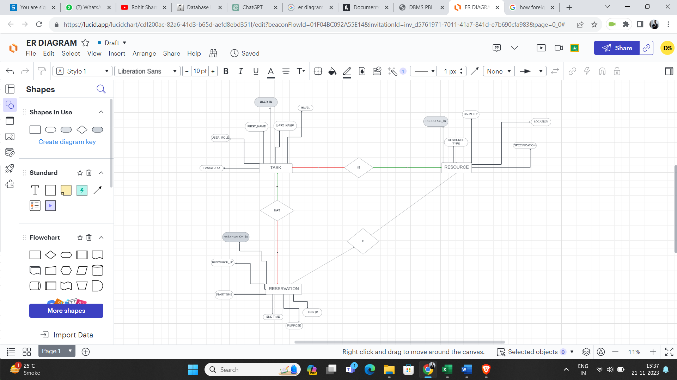
ER Diagram:-

Relational Model :-
User ID | First Name | Last Name | Email | Password | User Role
101 | John | Doe | Jd123@gmail.com | 201 | 58
102 | Jane | Smith | js123@gmail.com | 202 | 48
103 | Mike | Johnson | mj123@gmail.com | 204 | 89
104 | Emily | Brown | eb123@gmail.com | 203 | 48
105 | Alex | Davis | ad123@gmail.com | 208 | 25
106 | Valli | Lorentz | Vl123@gmmail.com | 210 | 98
107 | Nancy | Greenbrty | ng@gmail.com | 212 | 85
User Table:-

Resource Table:-
Resource ID | Resource Type | Capacity | Location | Specifications
501 | 102 | 60000 | Agra | 2000
502 | 103 | 45000 | Delhi | 1500
503 | 104 | 55000 | Chennai | 1800
504 | 105 | 50000 | Mumbai | 1600
505 | 106 | 48000 | Lucknow | 1200
506 | 107 | 51000 | Aligarh | 3000
507 | 108 | 59000 | Duhai | 1200

Reservation Table:-
Reservation ID | Resource ID | User ID | Start Time | End Time | Purpose
1001 | 101 | 8000 | 11:00 | 12:00 | Income Tax
1002 | 102 | 6000 | 12:00 | 1:00 | Income Tax
1003 | 103 | 7500 | 1:00 | 2:00 | Income Tax
1004 | 104 | 7000 | 2:00 | 3:00 | Income Tax
1005 | 105 | 5000 | 3:00 | 4:00 | Income Tax
1006 | 106 | 8000 | 4:00 | 5:00 | Income Tax
1007 | 107 | 1000 | 5:00 | 6:00

Queries and Output

CREATE TABLE User (
UserID INT PRIMARY KEY,
FirstName VARCHAR(50),
LastName VARCHAR(50),
Email VARCHAR(100) UNIQUE,
Password VARCHAR(255), -- Hashed and salted password
UserRole VARCHAR(50)
);

CREATE TABLE Resource (
ResourceID INT PRIMARY KEY,
ResourceType VARCHAR(50),
Capacity INT,
Location VARCHAR(100),
Specifications TEXT
);

CREATE TABLE Reservation (
ReservationID INT PRIMARY KEY,
ResourceID INT,
UserID INT,
StartTime DATETIME,
EndTime DATETIME,
Purpose TEXT,
FOREIGN KEY (ResourceID) REFERENCES Resource(ResourceID),
FOREIGN KEY (UserID) REFERENCES User(UserID)
);

References:-
- Smith, J. (2018). "Database Systems: Design, Implementation, and Management."
- Brown, A. (2020). "Payroll Management: A Comprehensive Guide."
- Oracle Documentation. (https://docs.oracle.com/en/database/) ● Kavanagh, R., Thite, M., & Johnson, R. (2019). "Human Resource
Information Systems: Basics, Applications, and Future Directions."
- Noe, R. A., Hollenbeck, J. R., Gerhart, B., & Wright, P. M. (2019). "Human Resource Management: Gaining a Competitive Advantage."

